Color Star

Advanced Talking Color Identifier
Light Detector and Light Analyzer

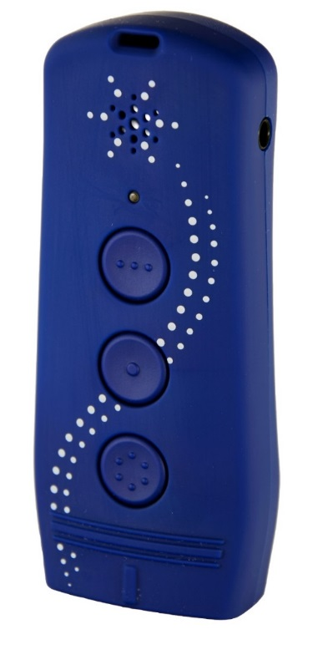

________________________________________________________________________________

MANUAL

EN

Table Of Contents

1. Introduction 3
2. Device description 4
3. Charging the battery 6
4. How to turn ON/OFF 6
5. Color Star’s functions 6
5.1. Color measurement 7
5.2. Identifying patterns and measuring color contrast 7
5.3. Light detector and light analysis 7
5.4. Comparing colors 8
5.5. Color analysis 9
5.6. Repeat the color announcement 9
5.7. Volume control 9
6. Having trouble with your Color Star? 10
7. Safety and Cleaning 11
8. Technical Data 12
9. Guarantee and Service 13
10. Disposal of used electronic devices 14
11. Symbols used 15
12. Manufacturer 16

1. Introduction

Color Star is a high-performance color identifier with leading-edge technology that recognizes up to 1000 different nuances of color and offers clear and natural speech. In addition, it compares colors, identifies patterns and measures color contrast. It not only recognizes the color of LED-lights, but also measures the intensity of ambient light.

There are different methods for measuring color. Color Star uses a sophisticated analysis based on the RGB (red-green-blue) color sensor module. This method analyzes color the same way that the three receptors of the eye do.
Color Star announces colors in two different ways:
- using universal color names (scientific names developed by the International Commission on Illumination CIE)
- using artistic (or „traditional“) color names that are used in everyday language

Each and eveyone of us has his or her own perception and interpretation of color and light. Color Star is programmed in a more general way. The colors may thus vary from the user‘s own individual perception of colors, but the measurements remain highly precise according to the programming.

2. Device description

Measuring sensor

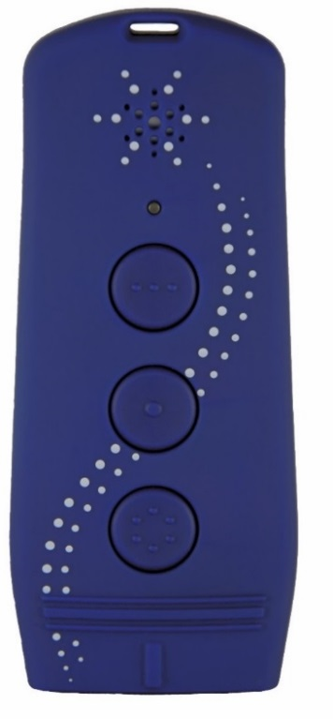
Color measurement button (A)
Measuring contrast and patterns

Light measurement button (B)
Light analyzer
Color comparison

Light-emitting diode

Volume button (C)
Battery status
Socket
For pendrive charger cable

Earphone jack
3,5 mm Standard

Speaker
Eyelet for lanyard
Reset-Hole

Hold your Color Star device in front of you and in such a way that the control buttons are facing you and the three upper horizontal lines (tactile markings) - above the color measurement button - are directed away from you.

The front of the device
Above the three horizontal lines you will find a (centrally located) short marking that is perpendicular to the horizontal lines. This easily palpable line shows in the direction of the measuring sensor which is located at the top end of the device, on the upper narrow side.
Below the horizontal lines, you will find three round tactile buttons (A, B, C) all lined up in a vertical row. All three buttons have clear tactile markings and allow users to perform all operating steps. If you continue to run your fingers further down, you will come across a small light-emitting diode that gives the charge status of the battery. Then, further down, a star shaped grille covers the speaker installed underneath. At the bottom end of Color Star‘s case there is an eyelet that you can attach a lanyard to, if you wish.
From top to bottom, the button closest to the measuring sensor is the color measurement button (A) recognizable with its 6 tactile dots arranged in a circle. The next button is the light measurement button (B) with one tactile dot in the middle and the last is the volume measurement button (C) with three raised dots in one row.

The narrow sides
The measuring sensor is situated on the devices‘ top end or upper narrow side. You can find the earphone jack on the lower left narrow side of the device. Right on the other side, on the lower right narrow side, you will find the socket for the pendrive charger cable. The lower narrow side features the small (1mm) hole for the reset function.

The back of the device
On the back of the device you will find a sticker with Color Star‘s serial number and four countersunk screws that hold the case together.

 | Note:  An audio manual (on CD or pendrive) for blind and visually impaired users is included in the package content.

3. Charging the battery

The device is equipped with an integrated battery. As soon as the battery becomes weaker, you will hear a siren-like noise. This is a reminder to recharge your battery using the pendrive charger cable included in the package content.
The recharging process starts with a short „battery is being recharged“. The diode emits a red light. As soon as the charging process has finished, you will hear „battery recharged“ and the diode will emit a green light. Battery charge time is approximately two hours. For information about the battery status, hold the volume button (C).

4. How to turn ON/OFF

Turn ON Color Star by pressing the color measurement button (A). Turn OFF the device by holding the color measurement (A) and light measurement (B) buttons simultaneously. To save energy, Color Star will go into standby after 1 minute idle. Five seconds before the device turns itself off automatically, you will hear a notification sound.

5. Color Star’s functions
Button /  Pressure | Color measurement button (A) | Light measurement button (B) | Volume button (C)
Short | Turn ON  Color measurement | Color comparison | Volume control
Hold | Color contrast measurement | Light detector including light analysis | Battery charge level
Short A & B | Repeat the color announcement | Repeat the color announcement
Hold A & B | Turn OFF | Turn OFF
Short B & C |  | Select color name (universal / artistic) | Select color name (universal / artistic)

5.1. Color measurement

To ensure correct color measurement please position the measuring sensor of your Color Star at a right angle to the surface you wish to analyze and briefly press the color measurement button (A). The color will be announced in a clear spoken voice.
Be sure that no light enters between the sensor and the object surface, otherwise the measurement is not reliable or no measurement is possible at all. Also be sure to keep the device as still as possible during measurement.

5.2. Identifying patterns and measuring color contrast

Press and hold the color measurement button (A) and scan your Color Star over the surface of an object or a document. If the signal sequence is fairly constant, the surface you are measuring is unicolor. Higher-pitched signals stand for lighter colors and lower-pitched signals for darker colors. If the tone sequence varies, the surface is patterned (e.g. writing). If you hear a dynamic and vibrant signal sequence, the surface is multicolored (e.g. in a picture/photo).
The signal sequence will tell you if there is writing on a document, where the writing is, if there are pictures included and where exactly these are.

5.3. Light detector and light analysis

This function enables you to detect light sources – be it natural or artificial – and gives information about the color hue and the intensity of the light. Color Star can recognize 15 (color) tones with intensities between 0 and 10000.
To be able to detect light sources hold the light measurement button (B) and move the device in different directions or point the device in the direction of the assumed light source (for example in direction of a window in a room). You will be able to determine the intensity of the light source by the pitch of the signal that you hear.
The higher the pitch, the stronger the light. As soon as you think you have found the light source, release the button. Then you will hear information about the color tone, e.g.: „The color of the light is white. Intensity 1000“.
Using this function you can also detect if a light emitting diode on your phone, your PC etc. is switched on or not. It will also help you recognize its color tone and intensity. All you need to do is to point the device in the direction of the light source and hold the light measurement button (B). While moving the device around or in the vicinity of the light source you will hear a signal. The higher the pitch of the signal, the closer the device is to the light source.
As soon as you release the button you will hear information, e.g.: color tone of the light is red, intensity 256“.

5.4. Comparing colors

This function enables you to compare the color of the last color measurement with the color measured previously.
Press Color Star‘s measuring sensor onto the object surface that you would like to analyze and briefly push the color measurement button (A).
After the device has given you the color measurement of this object, hold the device onto a different surface and briefly press the light measurement button (B). Listen to the information given by the device: e.g.: “Colors are the same”, “Colors are slightly different”, “Colors are appreciable different” or “Colors are strongly different”.
If only one color measurement has been made, no color comparison is possible; the information you get will be of this one measurement.

5.5. Color analysis

The result of the color analysis is announced in two different ways:
Using universal color names (following CIE guidelines) and using artistic (or „traditional“) color names. By simultaneously holding the buttons (B) and (C) you can change from one color name to the other.

5.6. Repeat the color announcement

To be able to listen to the result of the color analysis again, please press the buttons (A) and (B) simultaneously. The last color announcement will be repeated.
After having turned off the device, the last result will be deleted from the memory.

5.7. Volume control

The device has five different volume levels.
By briefly pushing the volume control button (C) you will be told the current volume level.
Every time you continue to push this button, the volume will increase by one level. After having reached level five, the device will automatically go back to level one. If it takes you longer than three seconds to change from one volume level to the next, the device will repeat the last volume announcement.

6. Having trouble with your Color Star?

If you hear loud siren-like noises, be sure to recharge your battery (see also chapter three „charging the battery“).
In case the device is not functioning, connect the device to the pendrive-charger (included in the package content) for at least an hour. Then try switching Color Star on again.
If there is no reaction, take a sharp object – as for example the wire of an ordinary paper clip. Introduce the wire into the small (1 mm) reset hole on the lower narrow side of the device and press briefly.
If you hear the startup melody, Color Star is now ready for use again. If this reset measure does not function, the device needs to be repaired. To do so, please get in touch with the manufacturer.
Please note that the color measurement depends on the texture of the object that you wish to examine. A rough knitted sweater can seem darker than it is.
In addition, if you are measuring a translucent textile (as is the case with a rough knit) the underground surface can show through and thus distort the result. We recommend you fold the fabric several times, smooth it out and then push the fabric against the measuring sensor with your finger (from behind the fabric). Then examine the textile again.

7. Safety and Cleaning

- Clean the surface of the device with a soft and lightly moist cloth.

- Make sure that no moisture enters the device. In case of moisture, dry the case with a cloth and leave the case to dry entirely.

- Avoid the measuring sensor getting dirty. This can be the case when measuring the color of moist or creamy textures, as e.g. lipsticks.

- Do not expose to extreme temperature. Functional safety of Color Star can only be guaranteed at temperatures between 0° C and +40° C.

- Use Color Star only in undamaged condition.

- The device can only be opened by an authorized technician.

- Please note that this device is no child’s toy.

- If you are using earphones, please take into consideration that listening at high volume can damage your hearing.

8.Technical Data

Dimensions: | Length: 90 mm (11/32 “ inches), Width: 35 to 38 mm  (1 and 3/8” to 1 and 7/16” inches), Height: 14 to 18 mm (17/32” to 25/32” inches)
Weight: | 42 g (0.09 lb.) including battery
Power supply: | Integrated 1 x 3.7V / 550 mAh Lithium-Polymer rechargeable battery
Color recognition: | Recognizes up to 1000 different shades of color
Light recognition: | Recognizes up to 10.000 lightintensities
Speech output: | Many languages availabe;best souncquality
Volume control: | 5 different volume levels
earphone jack: | 3,5 mm jack
Reliable temperature range: | 0° to 40° Celsius (32° to 104° Fahrenheit)
USB  port: | Micro USB port for pendrive charger cable
More details: | Eyelet to attach lanyard
Package contents: | Color Star Talking Color Identifier, stereo earphone, 5V / 1A per micro-USB cable adapter, storage pouch and 1 x lanyard, manual in blackprint, manual on CD or pendrive with audio manual

9. Guarantee and Service

Guarantee starts as of the date of invoice receipt and covers:

- 24 months product-guarantee

- 12 months accessories guarantee (accessories: earphone etc.)

- 6 months guarantee for parts subject to wear and tear (e.g.: rechargeable battery)

- No guarantee can be given for external data carrier (e.g. pendrive included in package content)

If the device is eligible for repair under the device warranty the manufacturer (CareTec) will take back the device for free of charge reparation or replace the device with a new one – if necessary. CareTec reserves the right to make any changes or improvements to its products without further notice.
In case of improper usage of the device – as immersion into chemically aggressive liquids, dropping the device, submitting the device to extreme temperatures, opening of the case or improper handling of the device – the warranty claim expires. In case of a complaint or if repair is necessary, please get in touch with the manufacturer.

10. Disposal of used electronic devices

 | - Devices labeled with this sign are to be disposed of separately from ordinary household waste.  - Follow the local regulations when disposing of the device. Dispose of used devices according to the WEEE 2002/96/EC (Waste Electrical and Electronic Equipment) regulation. For further information please contact your local authorities.  - Used and fully discharged batteries should be disposed of in designated collection containers, at a suitable recycling facility, or via an electrical retailer. You are required by law to dispose used batteries.

 | Notice:  - Pb-Dd-Hg, these chemical symbols are found on contaminant-laden batteries:  - Pb = contains lead;  - Cd = contains cadmium  - Hg = contains mercury

11. Symbols used
 | - Warning

- Notice
 | - Does not belong in household waste
 | Information provided by the manufacturer

12. Manufacturer
The Color Star is a device developed by the company
CareTec International GmbH
CareTec has been developing and producing talking and tactile aids for the visually impaired, the blind and deaf-blind as well as the color-blind ever since 1988. Devices produced by Caretec are sold by distribution partners all over the world:
Simple aids: AutoGraph Signature guide, Wooffy T. - Tactile battery tester, AuPair socks sorter, Sherlock braille label writer, AMICO - Euro Cashbox, and the CashTest - Note and Coin Gauge with more than one million users in countries worldwide.
Sophisticated products: High-quality tactile drawing board DraftsMan Standard, color and light measurement aids such as Colorino, talking kitchen and bathroom scales such as talking kitchen scale Vivienne, commercial and scientific pocket calculators such as Platon - Scientific Calculator, tag reader Foxy Reader Set, an ultrasonic sensor for detecting objects, Power-Max® talking battery charger, talking tape measure Talking Tape Measure, several Braille watches and white canes.
Earlier developments: The first blood glucose meter that can be used by the blind all on their own; Due to temporary production-stop of the test strips this product is currently not available; resumption of production is planned. First German-speaking braille-organizer (resumption of production is not planned but can technically be resumed at any time; the market is currently saturated).

Awards: “Louis-Braille-Prize” awarded by the German Federation of Blind and Partially Sighted. “Winston Gordon-Prize” awarded by the Canadian Blind Union. First Mercur-Prize and five Mercur-acknowledgment awards by the Viennese Economic Chamber WKO.

CareTec International GmbH
Stubenbastei 1, A-1010 Wien, Österreich
Tel: +43 (0) 1 513-8081-0, www.caretec.at

Color Star EN_11_2017_V9.0

